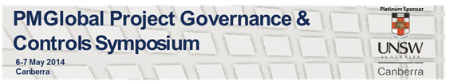

Great News!
The Directors of PMGlobal would like to invite you to join an extensive line up of keynote speakers and industry specialist for the re-established Project Governance and Controls Symposium (PGCS), now in its second year!
Returning to Canberra on May 6-7, 2014, PGCS is now the only Australasian symposium dedicated to promoting Project Performance Management and will again focus on the disciplines of project control and program, portfolio and project governance.
Proudly hosted by Platinum Sponsors, UNSW Canberra, the symposium will be held at the Australian Defence Force Academy (ADFA). This illustrious venue will put the spot light on the academic and industry issues and innovations in a two day program of symposium sessions and workshops.
Registrations are now available! Click here to find out more.

The 2014 Symposium will aim to:
-Provide cutting-edge presentations focused on the crucial role of effective project controls in facilitating effective project governance
-Celebrate the 11th anniversary of the introduction of Earned Schedule
-Provide a great opportunity to learn and exchange knowledge
-Provide a forum for education and the development of new skills across various industries and sectors within the Project Controls and Governance Management community
-Promote networking for business opportunities
-Promote the continuous improvement of industry standards
-Promote the continuous improvement and professionalism within the project management and the enterprise management community

International Keynotes Announced
Leading the charge are confirmed International Keynote presentations:

Lessons Learned from GAO Reviews of Federal Agency Capital Acquisition Programs and GAO Improvement Initiative is the USA – Ms Karen Richey
Ms. Karen Richey is an Assistant Director for the Applied Research and Methods Team at the Government Accountability Office (GAO). She is a senior cost analyst responsible for performing cost, schedule, and Earned Value Management analyses to support audit findings on a wide range of government programs. Certified by the National Defense University as a Chief Information Officer (CIO), Karen is also Level-III certified in the field of cost estimating and financial management. She has 22 years experience in the fields of cost estimating, scheduling, and EVM analysis.

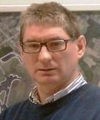
If Time is Money, Accuracy Pays Dividends: An Overview of Past and Future Project Management Research - Prof Stephan Vandervoorde
Mr. Stephan Vandevoorde is the head of the Airport Systems Division of CofelyFabricom N.V./S.A. Mr. Vandevoorde is a founding member and Director of the EVM Europe Association (www.evm-europe.eu) which aims to advance the uptake and use of the EVM method in Europe. He is also a past director of the PMI Belgium Chapter.
Mr. Vandervoorde has extensive experience in the use of EVM in the commercial sector. EVM is used as a project control tool by Fabricom for most of their projects. His particular interest is in EVM techniques which assist in evaluating and predicting project performance, including the newly developed Earned Schedule concept. He has published research papers validating the Earned Schedule method using real project data from Fabricom Airport Systems.

The ANAO Perspective on Effective Project Governance and Controls – Dr Tom Ioannou

Dr Tom Ioannou is a Group Executive Director with overall responsibility for the ANAO’s performance audit program for: defence and veteran’s affairs, health and human services, industry and government advertising. Before joining the ANAO he worked in the Commonwealth departments of Prime Minister and Cabinet, Finance, Health and the DMO’s industry division. He also spent four years in the Cabinet Office of the Victorian Department of Premier and Cabinet.
Mr. Stephen Hayes, will be also joining the world class line up at the Governance and Control Symposium.
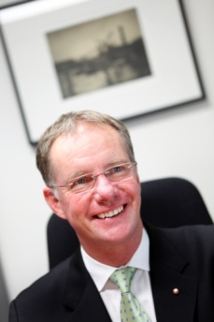
Stephen Hayes is the Managing Director and Chief Executive Officer of the International Centre for Complex Project Management, an independent international not-for-profit company that aims to better enable the global community to deliver complex projects and programs. He is working extensively in the international community as well as numerous government agencies and corporations to deliver this new global resource.
Stephen is also Chair of the International Complex Project Management Research Council, CEO of the Cooperative Research Centre bid for Managing Complex Projects and Programs, a Member of a number of Boards, Director of ICCPM North America, Director of ICCPM UK and a Councillor on a number of Australian Societies.

Find out more about the speakers by clicking here.

